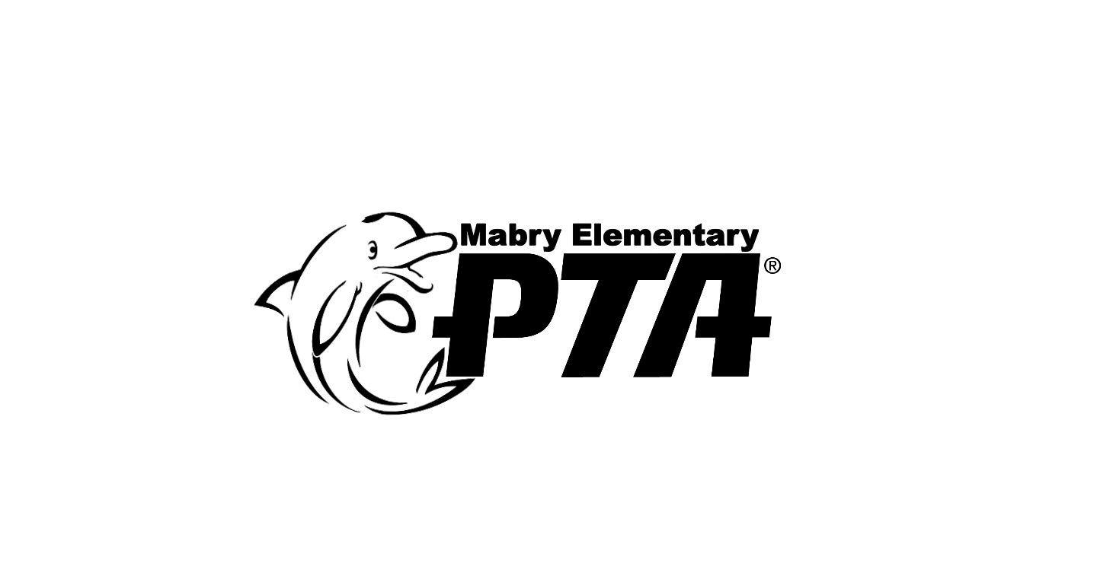

**Dale Mabry Elementary PTA To Award Dale Mabry Elementary Alumnus/Alumna $1,000 Scholarship**

Dear Hillsborough County Public School District College & Career Counselors,

The Dale Mabry Elementary PTA is pleased to announce it is now accepting applications for the annual Dale Mabry Elementary Alumnus/Alumna Scholarship. Hillsborough County Public School seniors who previously graduated from 5th grade at Dale Mabry Elementary and are current members of their school’s PTSA are eligible to apply for the $1,000 scholarship. The scholarship application is attached to this email. Applications and all required supporting documents must be received on or before April 1, 2018. The winner will be notified by May 15, 2018.

Questions should be directed to Caro Massari (813-767-3367) or [caromassari@yahoo.com](mailto:caromassari@yahoo.com).

Sincerely,

Caro Massari

Mabry Elementary PTA Scholarship Chair

*2017-2018*

*Executive Committee*

Melissa MacKinnon

*President*

Kelly McGraw

*VP Programs &*

*Services*

Brandi Whitney

*VP Volunteers & Membership*

Anne Williams

*VP Fundraising*

Nikki Armstrong

*VP Communications*

Jen Chan

*Treasurer*

Rachel Fenton

*Recording Secretary*

4201 West Estrella Street

Tampa, Florida 33629

813-872-5364